**CASE 1** Adding the items to the basket/shopping cart

**Descriptions:** Adding the items from website "ROZETKA" to the basket-button

**Step 1**: Open <https://rozetka.com.ua/ua/>

**Step 2:** Write "Laptop" to the search field 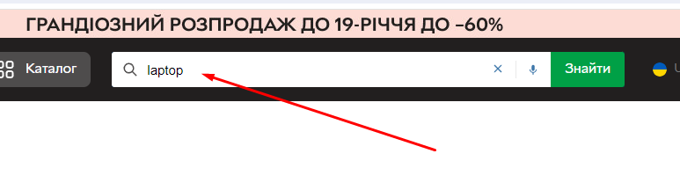

**Step 3:** Choose the laptop and click to the basket-button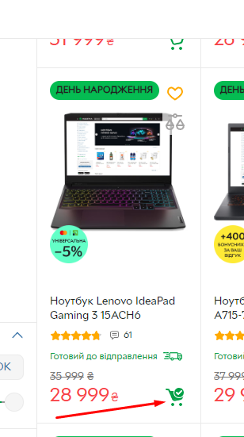

**Step 4:** Open the basket

**Expected result :** The laptop is into the basket 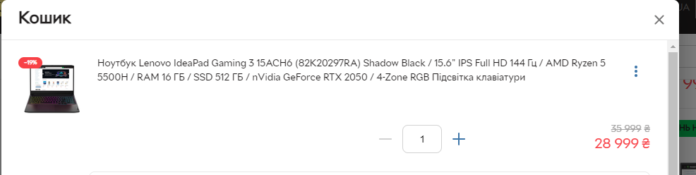

**CASE 2 Deleting item from the basket/shopping cart**

**Description:** Deleting item from the basket/shopping cart

**Step 1 :** Open <https://rozetka.com.ua/ua/>

**Step 2:** Click to the basket button

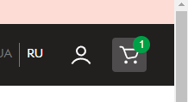

**Step 3:** Click to the kebab and delete

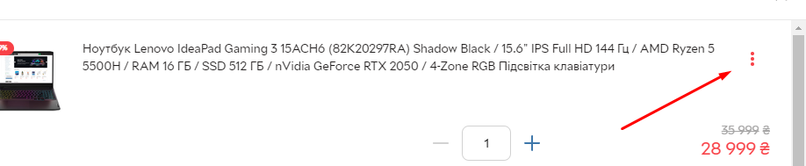

**Expected result :** The basket is empty

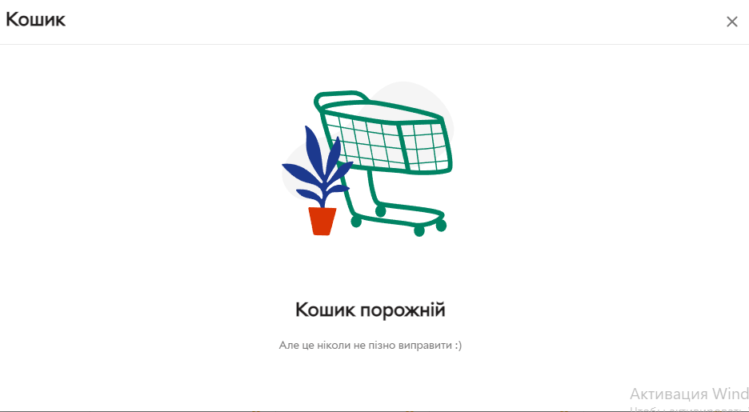

**CASE 3 Adding the items to the basket/ shopping cart and close the page and reopen again**

**Description:** Add the items to the basket / shopping cart and close the page and reopen the page 'ROZETKA' again

**Step 1:** Open https://rozetka.com.ua/

**Step 2:** Choose the laptop and add it to the shopping cart

**Step 3:** Open the basket and make sure the laptop is in the basket

**Step 4:** Close the page and reopen again in 20 minutes

**Expected result:** The laptop is still in the basket



**CASE 4 Adding the items that are sold out**

**Description:** Try adding the items that are sold out and check that it is impossible

**Step 1**: Open https://rozetka.com.ua/ua

**Step 2:** Write " Joy Sunday" to the search field

**Step 3:** Find the item that is sold out

**Step 4:** Try adding the items to the shopping cart

**Expected result:** The button for adding to the shopping cart is absent

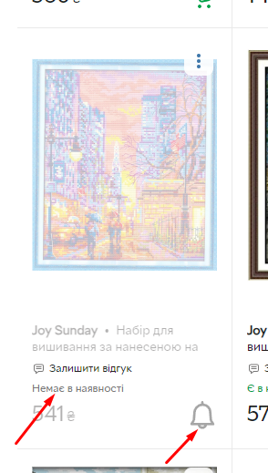

**CASE 5 Age validation**

**Description:** Try adding a bottle of vine and check the age validation request

**Step 1**: Open https://rozetka.com.ua/ua

**Step 2**: Write "vine" to the search box

**Step 3**: Try adding the vine to the shopping cart

**Expected result:** Appearing age validation pop-up

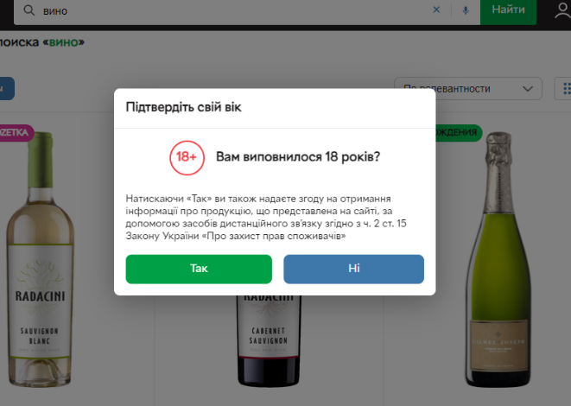

**CASE 6 Up-Selling and Cross-Selling Validation**

**Description:** Make sure that customers can find cross-selling/up-selling products after adding items into shopping cart

**Step 1**: Open https://rozetka.com.ua/ua

**Step 2**: Choose random product (for ex. laptop) and add to the shopping cart

**Step 3**: Open shopping cart and find cross/up-selling products

**Expected result:**: The cross-selling products are appropriated for choosing items

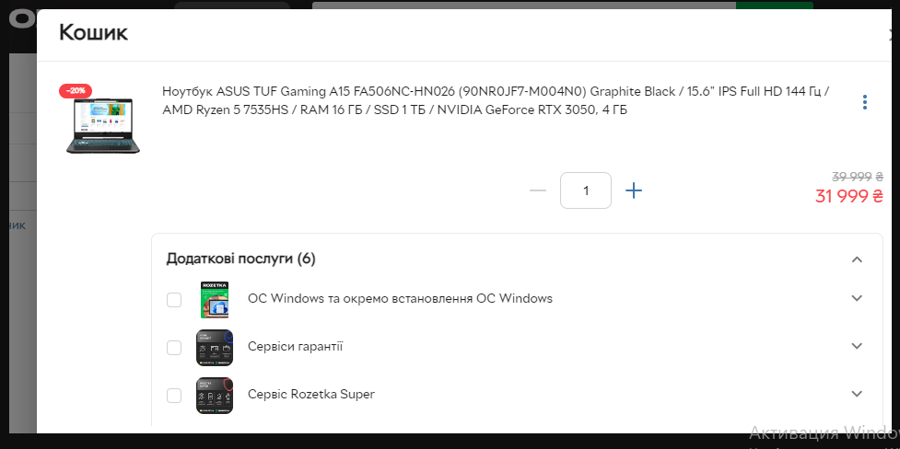

**CASE 7 Correlation between quantity and price**

**Description:** Check the correlation between quantity and price

**Step 1**: Open https://rozetka.com.ua/ua

**Step 2**: Choose random laptop and add it into shopping cart

**Step 3**: Open shopping cart and change the quantity from 1 to the 2

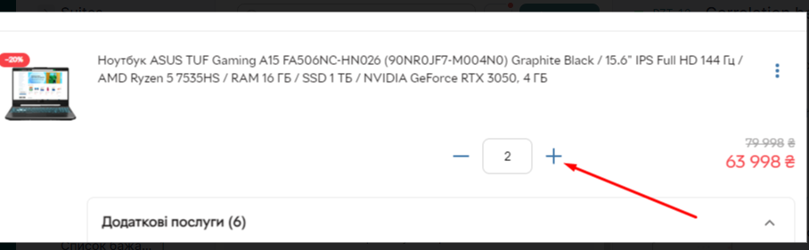

**Expected result:**: The price and the quantity should change

